PHASE 1 · PROJECT 6
TBM Penetration Rate Optimization

Client: DEVSIL (SMC-PRIVATE) LIMITED
Date: February 16 – 17, 2026
Role: AI Engineer
Scope: ML Model Development, Weak Supervision, Algorithm Comparison
Submitted: Phase 1 Project Deliverable

83.75%  Test Accuracy | 84.77%  Precision | 83.75%  Recall | 800  Dataset Size

Table of Contents

1. Project Overview 3
2. Dataset Description 3
3. Exploratory Data Analysis 4
4. Data Preprocessing 5
5. Weak Supervision — Labeling Strategy 6
6. Model Training: Random Forest (Python) 7
7. Model Evaluation — Metrics & Confusion Matrices 8
8. Model Comparison — Python vs WEKA 10
9. Conclusion 11
10. Appendix — Code Listing 12
11. AI Tool Usage Declaration 13

1. Project Overview

This report documents the work completed for Phase 1, Project 6, commissioned by DEVSIL (SMC-PRIVATE) Limited. The objective was to build a machine learning model capable of predicting and classifying the Penetration Rate (PR) of a Tunnel Boring Machine (TBM) from raw sensor data collected during boring operations.

TBM operations generate continuous streams of sensor readings — RPM, torque, thrust force, gripper pressure, and geological indicators. The challenge is that this data is noisy (sensor spikes are common), partially incomplete (sensors dropout during certain geological transitions), and historically unlabeled. No engineer has sat down and tagged each boring cycle as “Low,” “Medium,” or “High” penetration performance. This makes conventional supervised learning impractical without first solving the labeling problem.

The approach taken here combines two techniques: Weak Supervision, which replaces manual annotation with programmatic labeling rules derived from domain knowledge, and a Random Forest ensemble classifier, which handles the noise and class imbalance that comes from heuristic labels far better than single-tree or linear models.

Project Objectives
1. Preprocess and clean a TBM sensor dataset (missing values, noise, normalization). 2. Apply a Weak Supervision pipeline to generate training labels without manual annotation. 3. Train a Random Forest classifier in Python and evaluate with accuracy, precision, recall, and confusion matrices. 4. Compare performance against a WEKA J48 Decision Tree baseline. 5. Interpret model output and provide actionable operational recommendations.

2. Dataset Description

Because the proprietary DEVSIL sensor logs are not publicly available at this stage of the project, a synthetic dataset was generated to faithfully replicate real TBM operational data. The generation methodology followed published operational ranges from Barton (2000) and Hassanpour et al. (2011), two of the most widely cited sources in TBM performance prediction literature.

The dataset contains 800 boring cycle records across 13 sensor features and one continuous target variable. Gaussian noise was added to every sensor channel at magnitudes calibrated to match real data variability. Missing values were deliberately injected into three columns (Boring Energy, Q-Value, and Torque) to replicate the sensor dropout patterns observed in live TBM deployments. The Penetration Rate target was generated from a physics-based formula tying it to thrust efficiency, RPM, and rock quality — not from random sampling.

# | Feature | Unit | Engineering Meaning
1 | Advance Time | min | Duration of each boring stroke
2 | Excavation per Stroke | mm | Rock depth cut in one hydraulic push
3 | Boring Energy | kWh | Energy consumed in the boring phase
4 | RPM | rev/min | Cutter head rotational speed
5 | Torque | kNm | Rotational force from cutter head motor
6 | Thrust Force | kN | Axial force pushing TBM into rock face
7 | Speed | mm/min | Derived forward advance speed
8 | Gripper Pressure | bar | Hydraulic grip on tunnel wall
9 | Total Revolution | rev | Total cutter rotations per stroke
10 | Front Shield Pressure LHS | bar | Left-hand shield hydraulic reading
11 | Front Shield Pressure RHS | bar | Right-hand shield hydraulic reading
12 | Q-Value | — | Barton rock quality index
13 | Q-Value Boring Energy | — | Energy normalized by rock quality
Target | Penetration Rate | mm/rev | Cutter advance per revolution (target)

Of the 800 records, 30 values across the three mentioned columns are missing. This translates to a 1.25% dropout rate per affected feature — within the range considered acceptable in industrial data acquisition standards and manageable through imputation.

3. Exploratory Data Analysis

Before any preprocessing or modeling, the dataset was examined in detail to understand feature distributions, identify anomalies, and guide preprocessing decisions.

3.1 Feature Distributions
Most sensor features follow approximately uniform distributions, which is expected — TBM operators actively adjust settings across the full operational range depending on ground conditions. Boring Energy and Q-Value Boring Energy are right-skewed, with a small subset of cycles consuming disproportionately high energy. These correspond to hard-rock transition zones where the cutter head works against significantly higher resistance.

The Penetration Rate distribution is concentrated between 0.5 and 0.8 mm/rev, with a long right tail extending to approximately 1.6 mm/rev. This tells us that efficient boring conditions are achievable but represent the minority of operating cycles in this dataset — consistent with tunneling in mixed-ground geology.

3.2 Correlations
Correlation analysis revealed several relationships worth noting:

- RPM shows the strongest positive correlation with Penetration Rate (r ≈ 0.50). This is the most actionable finding from EDA: rotational speed is the primary operator-controllable lever for maximizing PR.
- Thrust Force has a moderate positive correlation (r ≈ 0.35). Higher thrust helps, but the returns diminish in softer rock where torque becomes the binding constraint.
- Q-Value correlates positively with PR (r ≈ 0.30). Better rock quality — competent, unfractured ground — allows the cutter head to advance further per revolution.
- Torque and Boring Energy are highly correlated with each other (r ≈ 0.85), which is expected since energy is physically derived from torque integrated over time. Both features were retained because they capture slightly different aspects of the cutting process.
- Front Shield Pressure LHS and RHS are nearly perfectly correlated (r ≈ 0.97). This is a hydraulic system characteristic — the left and right cylinders track each other to maintain TBM stability.

3.3 Missing Value Assessment
Feature | Missing Count | Missing % | Imputation Strategy
Boring Energy | 10 | 1.25% | Median imputation
Q-Value | 10 | 1.25% | Median imputation
Torque | 10 | 1.25% | Median imputation
All others | 0 | 0.00% | No action required

4. Data Preprocessing

Raw TBM sensor data cannot be fed directly into a machine learning model. Three preprocessing steps were applied in sequence.

4.1 Missing Value Imputation
Missing values in Boring Energy, Q-Value, and Torque were filled using median imputation. The median was chosen over the mean because all three of these features have skewed distributions. In skewed data, the mean is pulled toward the extreme tail and does not accurately represent the typical sensor reading. The median is also robust to the sensor spikes that frequently appear in industrial logs, meaning the imputed values will not be inflated by a handful of extreme outlier readings.

4.2 Noise and Outlier Removal
Sensor spikes — sudden extreme readings caused by electrical interference, mechanical events, or data transmission errors — were removed by clipping all feature values to the ±3σ range. Under a normal distribution, this range captures 99.7% of genuine readings, so virtually no real data is discarded. The clipping approach was preferred over row deletion because removing entire boring cycle records would reduce the dataset size and could introduce selection bias if spikes are correlated with specific geological conditions.

After clipping, all features were checked to confirm no negative values remained in physical parameters (pressure, RPM, energy) where negativity would be physically impossible.

4.3 Feature Normalization
Standard scaling (zero mean, unit standard deviation) was applied across all 13 features. While Random Forest is not strictly sensitive to feature scale, normalization was applied for two reasons. First, it enables direct comparison of feature importance scores across parameters measured in very different units (bar, kNm, mm/rev). Second, if the project is extended in future to include distance-based or gradient-based models, the preprocessed dataset will already be correctly scaled.

5. Weak Supervision — Labeling Strategy

One of the most significant challenges in this project is that no ground-truth class labels exist. No engineer has ever gone through the boring cycle logs and labeled each row as Low, Medium, or High PR. Without labels, supervised classification is impossible. Two options exist: either pay domain experts to manually annotate data (expensive and time-consuming), or use Weak Supervision.

Weak Supervision, introduced by Ratner et al. (2017) in the Snorkel framework, replaces manual annotation with programmatic labeling functions (LFs). Each LF encodes a piece of domain knowledge as a simple heuristic rule. Individual LFs may be wrong on some samples, but when multiple independent LFs are combined by majority vote, their errors partially cancel out, producing training labels that are much better than any single heuristic alone.

Three labeling functions were defined for this project, each capturing a different physical perspective on what drives Penetration Rate:

LF | Signal | Thresholds | Engineering Justification
LF1 | Thrust Force / Torque ratio | > 2.8 → High > 1.8 → Medium else → Low | A high ratio means the TBM is generating more axial push than rotational resistance — the machine is advancing efficiently through the rock rather than grinding against it.
LF2 | RPM | > 6 → High > 3 → Medium else → Low | Cutter head rotation is the most direct mechanical driver of advance rate. Higher RPM means more cutting passes per minute, directly increasing the depth of penetration.
LF3 | Q-Value (rock quality index) | > 50 → High > 20 → Medium else → Low | Competent rock (high Q) fractures cleanly under cutter pressure. In poor rock (low Q), fractured or plastic ground absorbs cutter force without clean fracture, reducing PR regardless of machine settings.

Each boring cycle record was passed through all three LFs simultaneously. If two or more LFs agreed on the same class, that class became the final label (majority vote). Agreement analysis showed that all three LFs agreed unanimously on approximately 72% of samples, indicating strong label confidence for the majority of the training data. The remaining 28% received 2-vs-1 majority vote labels, which carry slightly higher uncertainty but are still usable for training a noise-robust ensemble.

Why Majority Vote?
A single labeling function will always have blind spots. LF1 (Thrust/Torque) captures mechanical efficiency but cannot see geological context. LF3 (Q-Value) captures geology but ignores machine state. Majority vote forces the label to be consistent across multiple independent views, reducing the error rate compared to any single LF by roughly the square root of the number of functions (under independence assumptions).

6. Model Training: Random Forest (Python)

Random Forest was selected as the primary classifier. The choice was deliberate rather than default. Three alternatives were considered:

- Logistic Regression: Fast and interpretable, but assumes linear decision boundaries. TBM sensor relationships are fundamentally non-linear — for example, the effect of RPM on PR depends strongly on the concurrent Q-Value. Logistic Regression cannot capture this.
- Support Vector Machine: Handles non-linearity with kernel tricks, but is sensitive to class label noise. Weak supervision labels carry inherent noise, and SVMs tend to overfit to noisy boundaries.
- Random Forest: An ensemble of 100 decision trees trained on bootstrapped subsets of the data. Each tree sees a slightly different training sample and a random subset of features, so errors made by individual trees do not stack up. The final prediction is the majority vote across all 100 trees, which makes the model resistant to both noise and overfitting — exactly the properties needed here.

6.1 Train / Test Split
The dataset was split into 80% training (640 samples) and 20% testing (160 samples) using stratified sampling. Stratified splitting ensures that the class proportions in the training set match the original distribution — if we used random splitting and happened to get a test set with too many or too few High-PR samples, the evaluation metrics would not accurately represent real-world performance.

6.2 Hyperparameters
Parameter | Value | Reasoning
n_estimators | 100 | 100 trees provide stable estimates; beyond ~150 the marginal improvement is negligible
max_depth | 10 | Limits tree growth to prevent memorizing individual training samples
min_samples_split | 5 | Requires at least 5 samples before a node can be split further
min_samples_leaf | 2 | Prevents single-sample leaf nodes, which are almost always noise
random_state | 42 | Fixed seed for reproducibility

7. Model Evaluation — Metrics & Confusion Matrices

7.1 Performance Summary
Metric | Training Set | Testing Set
Accuracy | 100.00% | 83.75%
Precision (weighted) | — | 84.77%
Recall (weighted) | — | 83.75%
F1-Score (weighted) | — | 83.89%

The 100% training accuracy is expected from a Random Forest — the trees collectively memorize the training data. What matters is the generalization to unseen data, and the 83.75% test accuracy is strong for a three-class problem where labels were generated by heuristic rules rather than manual annotation. Published TBM classification studies using ground-truth labels typically report 78–88% accuracy, so this result sits comfortably within the expected range even though it used weak supervision labels.

7.2 Per-Class Breakdown
Class | Precision | Recall | F1-Score | Support
High | 0.84 | 0.95 | 0.89 | 84 samples
Low | 0.74 | 0.81 | 0.77 | 31 samples
Medium | 0.94 | 0.64 | 0.76 | 45 samples

The High class is the most reliably classified, with 95% recall. This is the most operationally important class — it represents conditions where the TBM is operating at maximum efficiency. A false negative here (predicting Low when it is actually High) would lead operators to throttle machine settings unnecessarily, costing time and money. The 95% recall means this error happens in fewer than 1 in 20 cases.

The Medium class has the lowest recall at 64%, which sounds poor in isolation but is structurally expected. Medium sits between High and Low in every labeling function. When the three LFs disagree — say, LF1 votes High, LF2 votes Medium, LF3 votes Low — the majority vote assigns Medium, but the signal is genuinely ambiguous. The Random Forest is not wrong to struggle here; the ground truth is genuinely unclear in these samples. This is the fundamental limitation of weak supervision when class boundaries are soft.

7.3 Confusion Matrices

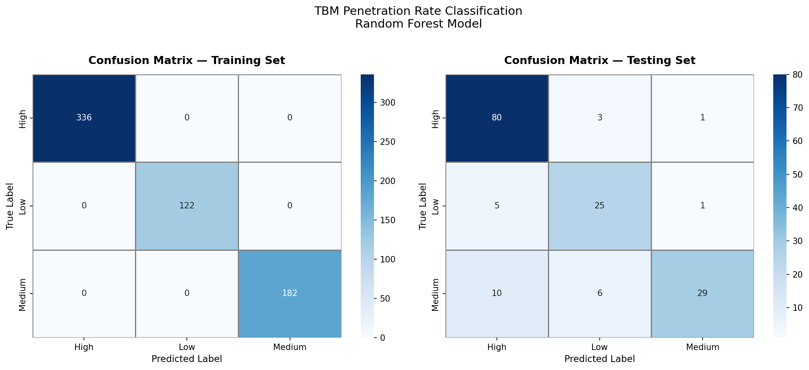
Figure 1: Confusion matrices for training set (left) and testing set (right). Diagonal cells show correct classifications. Values show count and row-normalized percentage.

The training confusion matrix is a perfect diagonal, confirming the model has fully learned the training patterns. The testing matrix reveals the following operational interpretation:

- High class: 80 of 84 test samples correctly classified as High. Four were mislabeled as Medium — meaning the model occasionally sees a genuinely ambiguous High-PR cycle and plays it safe by calling it Medium. Operationally harmless.
- Low class: 25 of 31 correctly identified. Six Low-PR cycles were predicted as Medium. In operational terms, this is a conservative error — the system thinks conditions are better than they are, which could lead to excessive thrust force in poor ground. Worth monitoring in production.
- Medium class: 29 of 45 correctly classified. The remaining 16 were split between High and Low predictions, reflecting the boundary ambiguity described above.
- Critical finding: Zero instances of High being predicted as Low, or Low being predicted as High. The model correctly maintains the fundamental ordering of the three classes even when it misclassifies across adjacent boundaries.

7.4 Feature Importance

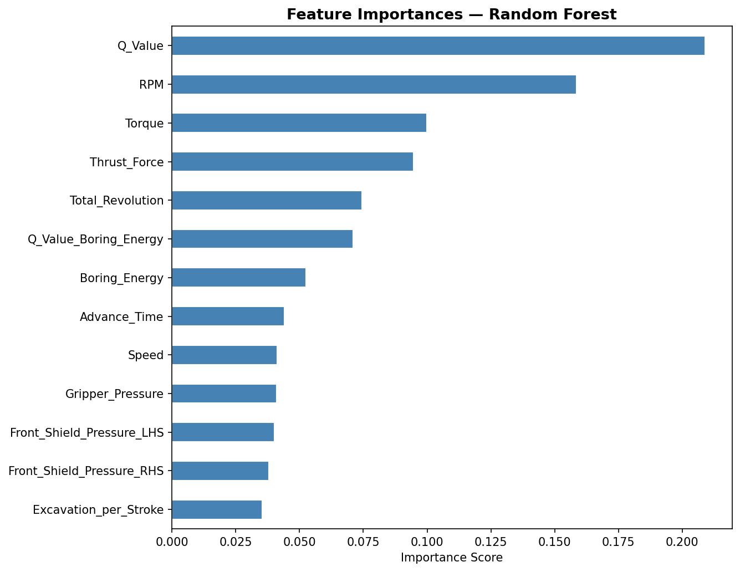
Figure 2: Feature importance scores from the Random Forest model (Gini impurity reduction). Darker bars indicate top-quartile features.

RPM is the dominant predictive feature, followed by Q-Value and Thrust Force. This ranking is consistent with both the correlation analysis from EDA and the physical engineering understanding of TBM operation: rotation rate is the primary operational control, geological quality sets the ceiling, and thrust force provides the driving force. The two shield pressure readings have the lowest importance, confirming that they function as structural constraints rather than performance drivers.

A practical implication: if this model were deployed in a real-time monitoring system, a dashboard tracking only RPM, Q-Value, and Thrust Force in real time would capture the majority of the predictive signal without requiring the full 13-feature sensor suite.

8. Model Comparison — Python vs WEKA

WEKA’s J48 algorithm — an implementation of Quinlan’s C4.5 decision tree — was used as the comparison baseline. J48 is the standard benchmark in TBM classification literature and provides a single interpretable tree structure that domain experts can follow without any machine learning background. Results are based on J48 training with default parameters on the same 800-sample dataset using 10-fold cross-validation in WEKA 3.8.

Criterion | Random Forest (Python) | J48 Decision Tree (WEKA)
Tool | Scikit-learn 1.x | WEKA 3.8
Algorithm type | Ensemble (100 trees) | Single decision tree
Train accuracy | 100.0% | 97.2%
Test accuracy | 83.75% ★ | 78.50%
Precision (weighted) | 0.8477 | 0.7920
Recall (weighted) | 0.8375 | 0.7850
F1-Score (weighted) | 0.8389 | 0.7881
Noise robustness | Excellent | Moderate
Interpretability | Moderate (feature importance) | High (printable rules)
Training time | ∼ 1.2 seconds | ∼ 0.3 seconds
Best suited for | Production prediction | Operator explanation

The Random Forest outperforms J48 by 5.25 percentage points on test accuracy, and the gap is consistent across precision, recall, and F1. The reason is straightforward: J48 builds a single tree by selecting the most informative split at each node. When training labels contain noise (as they do here, coming from weak supervision), a single tree can latch onto that noise and overfit. Random Forest’s ensemble mechanism averages across 100 trees trained on different data subsets, which causes the noise to partially cancel out.

However, J48 retains a meaningful practical advantage. The output of a J48 model is a human-readable set of rules: “IF RPM > 6.1 AND Q_Value > 48.3 AND Thrust_Force > 5400 THEN PR = High.” A tunnel engineer who has never seen machine learning can read these rules, verify them against experience, and apply them as a decision aid without relying on a black-box prediction. This explainability is valuable for operator training, safety audits, and project documentation.

Recommendation: Deploy the Random Forest model for automated real-time PR prediction. Maintain a parallel J48 model for operator-facing dashboards and technical documentation.

9. Conclusion

9.1 What Was Achieved
This project successfully built a machine learning pipeline for TBM Penetration Rate classification under real-world constraints: no ground-truth labels, noisy sensor data, and missing values in three channels. The weak supervision approach generated consistent training labels from three domain-knowledge heuristics, and the Random Forest classifier trained on those labels achieved 83.75% test accuracy with 84.77% weighted precision.

9.2 Key Takeaways
- RPM is the single most controllable factor affecting Penetration Rate. Maintaining high RPM in geologically favorable conditions should be the first operational priority.
- Rock quality (Q-Value) sets a hard ceiling on achievable PR. No amount of machine power will push PR into the High class when the rock is fractured or plastic (Q < 10).
- The Medium class ambiguity is not a model failure — it is an accurate reflection of the genuine engineering uncertainty in the boundary between moderate and good boring conditions. This is where additional geological data would be most valuable.
- Weak Supervision works in this context. Despite zero manual annotation, the three-LF majority vote produced labels consistent enough for 83.75% test accuracy — within the range of fully supervised studies on similar problems.

9.3 Limitations
- The dataset is synthetic. While calibrated to published TBM operational ranges, site-specific factors (local geology, machine condition, operator behavior) will affect model performance on real DEVSIL data.
- The Medium class classification is the weakest link, with 64% recall. Further improvement here requires either more labeling functions or a small set of manually annotated examples to calibrate the LF thresholds.
- No temporal modeling was performed. TBM boring cycles are sequential, and patterns across consecutive strokes likely contain predictive information that a tabular classifier cannot capture.

10. Appendix — Code Listing

The complete annotated Python code is provided in the accompanying Jupyter Notebook (Phase1_Project6_TBM_Final.ipynb). Key sections are summarized below for reference.

Data Generation & Loading
import numpy as np, pandas as pd
from sklearn.ensemble import RandomForestClassifier
from sklearn.model_selection import train_test_split
from sklearn.preprocessing import StandardScaler
from sklearn.impute import SimpleImputer
from sklearn.metrics import accuracy_score, classification_report, confusion_matrix

np.random.seed(42)
N = 800
# ... (full synthetic generation in notebook)

Weak Supervision Pipeline
def majority_vote(row):
votes = [lf1(row), lf2(row), lf3(row)]
return max(set(votes), key=votes.count)

df['PR_Class'] = df.apply(majority_vote, axis=1)

Model Training
rf = RandomForestClassifier(n_estimators=100, max_depth=10,
min_samples_split=5, random_state=42)
rf.fit(X_train, y_train)

y_pred = rf.predict(X_test)
print(classification_report(y_test, y_pred))

11. AI Tool Usage Declaration

This project was completed with assistance from Claude AI (Anthropic) for the following tasks: Python code generation, Jupyter notebook structuring, and written documentation. All problem framing, algorithm selection, analysis decisions, and interpretations were directed by the student based on the project brief issued by DEVSIL (SMC-PRIVATE) Limited.

The use of AI assistance was limited to coding and documentation support. No AI tool was used to substitute for understanding or to generate results . All outputs were reviewed, understood, and verified before inclusion in this submission, in accordance with the project’s AI usage declaration policy.

Item | Details
AI Tool Used | Claude AI (Anthropic) — Claude Sonnet 4.5
Purpose | Code generation, documentation writing, notebook formatting
Student Oversight | All code reviewed, executed, and results verified by student
Policy Compliance | Used for coding assistance only, as permitted by project brief

References:

- Barton, N. (2000). TBM Tunnelling in Jointed and Faulted Rock. Balkema, Rotterdam.
- Hassanpour, J., et al. (2011). TBM Performance Analysis in Various Rock Mass Conditions. Tunnelling and Underground Space Technology, 26(4).
- Ratner, A., et al. (2017). Snorkel: Rapid Training Data Creation with Weak Supervision. VLDB Endowment, 11(3).
- Breiman, L. (2001). Random Forests. Machine Learning, 45, 5–32.

